**THE SUPERIOR University LAHORE**

|  |
| --- |
|  |

**Faculty of Computer Science & IT**

**FINAL YEAR PROJECT**

**PROJECT PROPOSAL & PLAN**

**[AI BASED SMART ID]**

Project ID: **[FYP-BCSM-F22-041]**

**Project Team**

|  |  |  |  |  |
| --- | --- | --- | --- | --- |
| **Student Name** | **Student ID** | **Program** | **Contact Number** | **Email Address** |
| Umair Ahmed | Bcsm-f19-190 | BSCS | 03071030755 | Bcsm-f19-190@superior.edu.pk |
| M Naveed Qamar | Bcsm-f19-479 | BSCS | 03204308809 | Bcsm-f19-479@superior.edu.pk |
| Awais Safdar | Bcsm-f19-179 | BSCS | 03002933123 | Bcsm-f19-179@superior.edu.pk |

**[Ms. Amna Zeeshan]**

([Lecturer])

**[AI BASED SMART ID]**

**Change Record**

|  |  |  |  |  |
| --- | --- | --- | --- | --- |
| **Author(s)** | **Version** | **Date** | **Notes** | **Supervisor’s Signature** |
|  |  |  |  |  |
|  |  |  |  |  |
|  |  |  |  |  |
|  |  |  |  |  |
|  |  |  |  |  |
|  |  |  |  |  |
|  |  |  |  |  |

**Project Proposal**

**Project Title:** AI BASED SMART ID

# Executive Summary

One of the most important goals followed in most systems is to increase efficiency, reduce errors and enhance ease of data entry tasks such as better services in organizations. Therefore, the use of intelligent tools is the most important requirements for a management system to collect complete and accurate data and create complete information.

In management, use of new technologies is recommended to have smart systems and reduce human errors. This study is aimed to investigate “The entrance system using RFID and Face Recognition” and research population consists of students, workers etc.

Findings show that entrance checking system in organizations is usually done through the guards. Therefore, checking of employ through guards takes a lot of time and energy. thus, it leads to a waste of valuable time and energy of employ.

In view of above, it is, therefore, essential to use quick, efficient, and modern systems to overcome this problem. Thus, with the design and implementation of RFID entrance system and replacing the traditional system, time and energy waste could be avoided and entrance system could be promoted to an intelligent and integrated one. The designed system includes entrance of students at the University, entrance at different organizations etc. with its automatic identification through radio frequency. This system aims to create changes in this area.

The objective of our project is to address the following needs:

* Identification at entrance
* Avoiding time delays

And providing accurate, fast, and cost-effective solutions of above problems by using:

* Radio Frequency Identification (RFID)
* Face Recognition

# Introduction

The main idea of smart ID is to make organization more advanced with the use of RFID card. The card stores user balance in digital form. User can spend his/her money from card for only those things that he/she bought in organization premises boundary.

1. **Existing System / Competitive Analysis**

Many organizations are using different ways for identification most common method is barcode scan using cards and through security guards and in term of cashless payment organization use bank card but does not use same card which they use for identification

No organization is using face recognition for identification

* Superior University /University of Central Punjab / University of Management Sciences
* Orange line train payment method
* Jazz cash / Easypaisa.

1. **Problem Statement**

In current scenario student cards are either made of magnetic strip or of ordinary plastic cards. These cards have only limited space for data storage or in other words we say these cards do not store information rather they are just used as the means of identification.

* University Entrance
* Parking Issues
* Avoid Time Delay
* Inventory record
  + Library book
* Cash issues

## Proposed Solution

The Internet of things (IoT) describes the network of physical objects— “things” or Objects that are embedded with sensors, software, and other technologies for the purpose of connecting and exchanging data with other devices and systems over the Internet. by using this proposed system automatically data is fetched, manipulated, and recorded. This increases the ease of functions.

* For the security measures we are using the Walk-through gates embedded with RFID readers to check for the RFID cards.

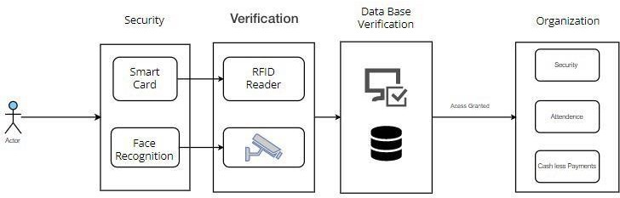

* Secondly, camera sensors are also implemented for the facial recognition.
* The data is gathered from the database which then give access to the students.
* Furthermore, customizations like adding café payments, library access, etc. can also be added to the smart card.

The central role of smart card is unique identification which is done using the unique id which is scanned using RFID reader hence according to the unique id the details are restored from the database. The database contains all the details related to all the modules and are interconnected.

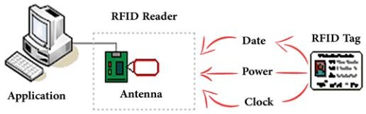

1. **Scope of the Project**

[12 pt, Calibri, Justified]

[*Major modules / features will be discussed in this section. Each module will be discussed in 5 to 6 lines.**Present the features that are included and the possible features that are excluded from your scope.*]

1. **System Architectural Design**

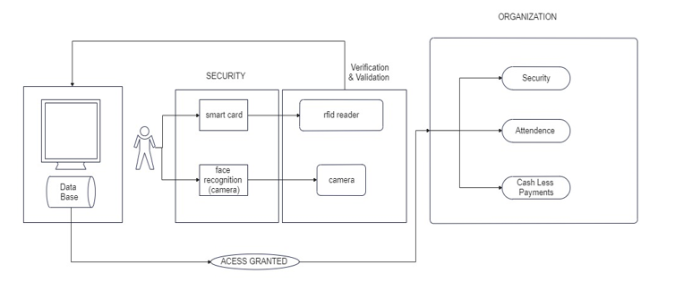

1. **Implementation Tools and Techniques**

[12 pt, Calibri, Justified]

[*Describe your methodology for implementation along with implementation tools*.]

1. **Project Plan**

[12 pt, Calibri, Justified]

[*This section describes how the project will be managed, including a detailed plan with milestones. Project Plan includes two things i.e. Work breakdown structure (WBS) and* *Gantt Chart consisting of Timeline with milestone.*]

* 1. **Work Breakdown Structure**

[*A work breakdown structure (WBS) is deliverable based decomposition of project scope. The WBS includes 100% of the work defined by the project scope and captures all deliverables – internal, external, interim – in terms of the work to be completed, including project management. You have to give division of responsibilities and duties among team members*.]

**Sample WBS**

1. **Project Management** 
   1. Work Breakdown Structure (WBS)
   2. Roles & Responsibility Matrix
   3. Change Control System
2. **Reports / Documentation**
   1. Final Documentation Introduction
   2. Literature / Markey Survey
   3. Requirements Analysis
   4. System Design
   5. Implementation
   6. Testing & Performance Evaluation
   7. Conclusion & Outlook
   8. End User Documentation
   9. Application Administration Documentation
   10. System Administrator Documentation
3. **System**
   1. Development Environment
      1. IDE
      2. Version Control
      3. Server
      4. Database
   2. Presentation Layer
      1. Deliverable 1
      2. Deliverable 2
      3. . . .
   3. Business Logic Layer
      1. Deliverable 1
      2. Deliverable 2
      3. . . .
   4. Data Management Layer
      1. Deliverable 1
      2. Deliverable 2
      3. . . .
   5. Physical Layer
      1. Deliverable 1
      2. Deliverable 2
      3. . . .

# 

# Roles & Responsibility Matrix:

The purpose of roles & responsibility matrix is to identify who will do what.

|  |  |  |  |  |  |
| --- | --- | --- | --- | --- | --- |
| **WBS #** | **WBS Deliverable** | **Activity #** | **Activity to Complete the Deliverable** | **Duration**  **(# of Days)** | **Responsible Team Member(s) & Role(s)** |
|  |  |  |  |  |  |
|  |  |  |  |  |  |
|  |  |  |  |  |  |
|  |  |  |  |  |  |
|  |  |  |  |  |  |
|  |  |  |  |  |  |
|  |  |  |  |  |  |
|  |  |  |  |  |  |
|  |  |  |  |  |  |
|  |  |  |  |  |  |
|  |  |  |  |  |  |
|  |  |  |  |  |  |

* 1. **Gantt Chart**

[*Gantt Chart consisting of Timeline with milestone. Specific items to include in this section are as follows:*

* *Timeline with milestones:* ***Gantt chart in Microsoft project 2013.*** *The following are required elements of your Gantt chart:*
* *Project duration is from the date your project is enrolled to the completion date:*
* *Each milestone is to be labeled with a title.*
* *Schedule all tasks not just “Design” or “Testing.” Break this schedule down to specific assignments.*
* *Each task is to be labeled with a title and person or persons assigned to the task.*
* *Subdivide larger items so that no task is longer than about one week*
* *Link tasks which are dependent on the completion of a previous task.*]
  1. **Empathy Map**

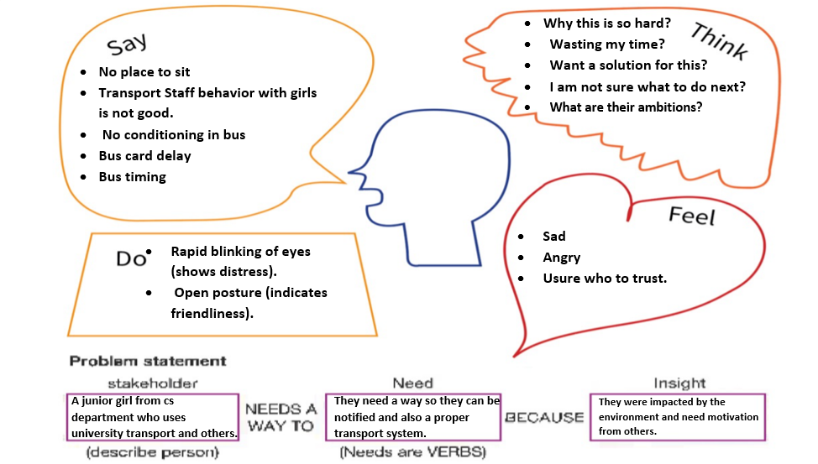

**References**

[12 pt, Calibri, Justified]

[*Give references to the resources you have consulted in finalizing your project topic.*]

**List of Faculty Proposed Changes**

**Project Title**

|  |  |  |
| --- | --- | --- |
| **Proposed Change** | **Proposed By** | **Supervisor’s Decision** |
|  | Name of Faculty Member(s) who proposed this change | Approved/Disapproved and/or Comments |
|  |  |  |
|  |  |  |
|  |  |  |
|  |  |  |
|  |  |  |
|  |  |  |

**Date: __________________ Supervisor’s Signature: ______________**

**APPROVAL**

|  |  |
| --- | --- |
| **Project Supervisor** | |
| Comments: ___________________________________________________________________ | | |
| _____________________________________________________________________________ | | |
| _____________________________________________________________________________ | | |
| _____________________________________________________________________________ | | |
| Name:______________________________ |  | |
| Date:_______________________________ | Signature:__________________________ | |

|  |  |
| --- | --- |
| **Project Manager** | |
| Comments: ___________________________________________________________________ | |
| _____________________________________________________________________________ | |
| _____________________________________________________________________________ | |
| _____________________________________________________________________________ | |
| _____________________________________________________________________________ | |
|  |  |
| Date:_______________________________ | Signature:__________________________ |